**LAB NO 2**

**VARIABLES AND OPERATORS**

**Practice Questions**

**1) Write a Dart program that calculates the result of integer division between two numbers and prints the quotient.**

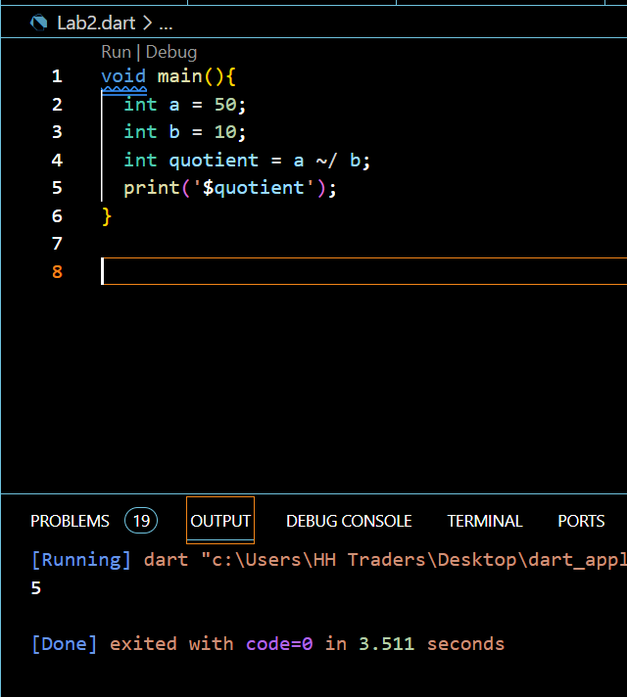

**2) Write a Dart program that takes an integer as input (initialize) and prints its negative value using the unary minus operator.**

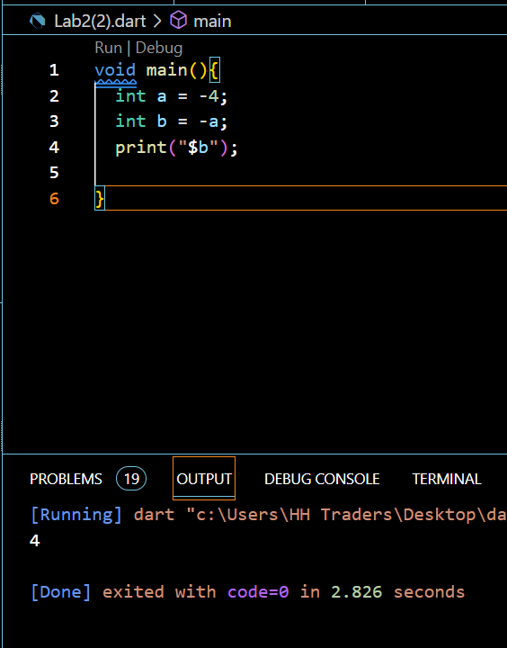

**3) Write a Dart program that compares two numbers and prints whether the first number is less than or equal to the second.**

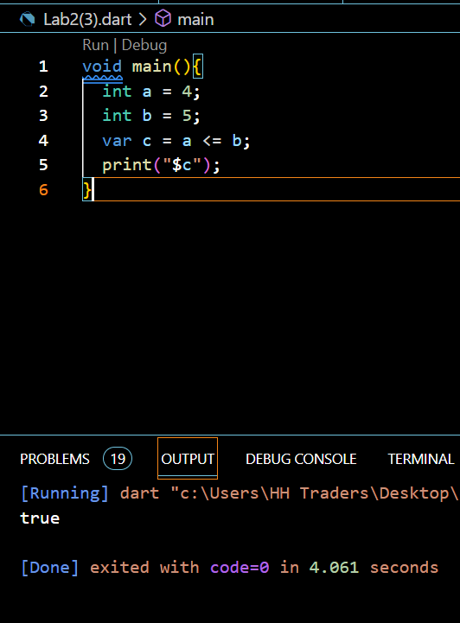

**4) Write a Dart program that compares two numbers and prints whether they are equal.**

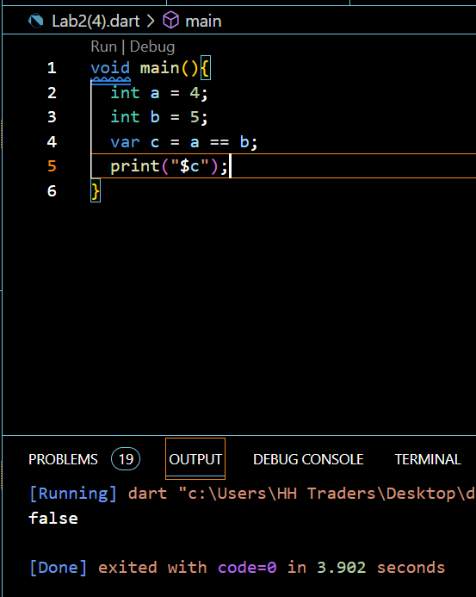

**5) Write a Dart program that compares two numbers and prints whether they are not equal.**

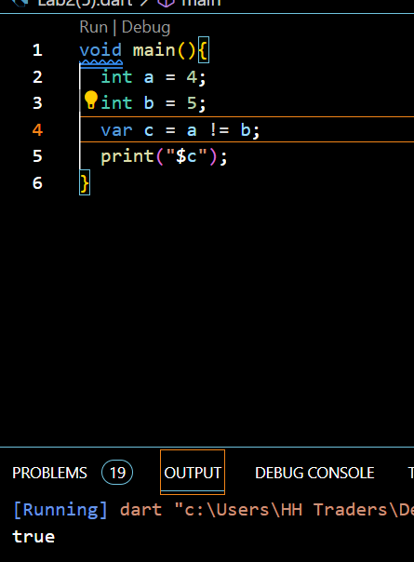

**6) Write a Dart program that initializes a variable with a default value and updates it only if the variable is null.**

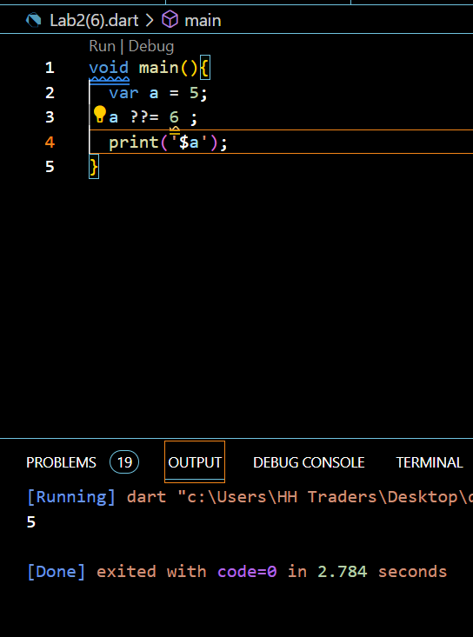

**7) Write a Dart program that checks if a person is eligible to vote based on their age and citizenship. The person must be at least 18 years old and a citizen.**

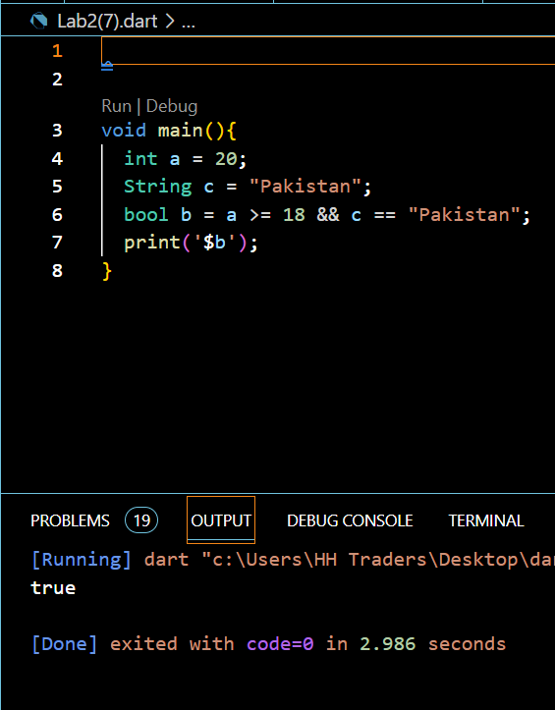

**8) Write a Dart program that checks if a user is eligible for a discount on a purchase. The discount is applicable if the user is a premium member or if their total purchase amount exceeds $100.**

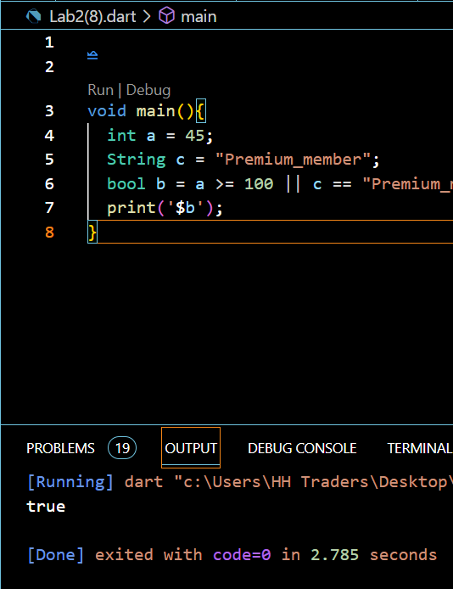

**9) Write a Dart program that checks if a user has not subscribed to a newsletter. The user will receive a promotional offer only if they are not subscribed.**

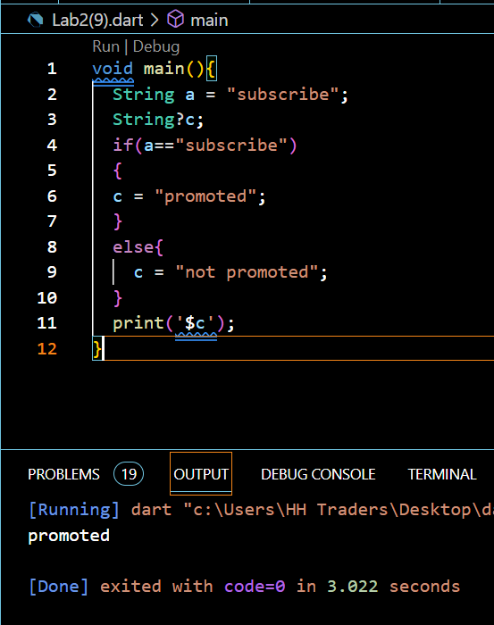

**10) Write a Dart program that determines whether a given number is positive or negative using the ternary operator.**

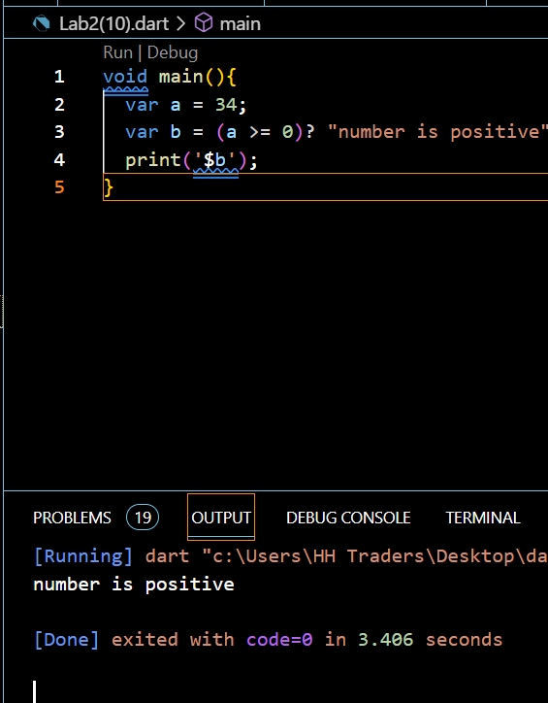

**11) Write a Dart program that determines whether a given number is even or odd using the ternary operator.**

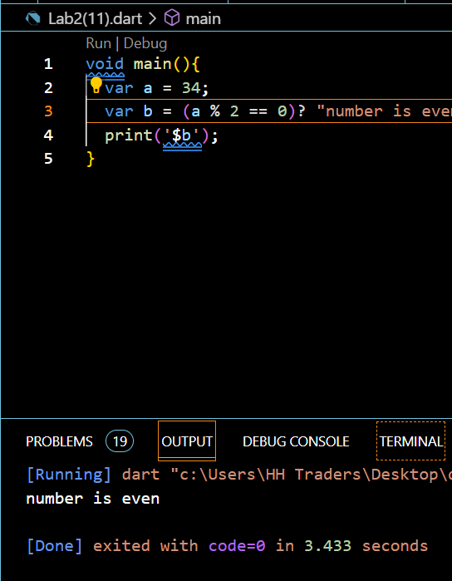

**12) Write a Dart program that checks if a person is eligible to vote based on their age, using the ternary operator.**

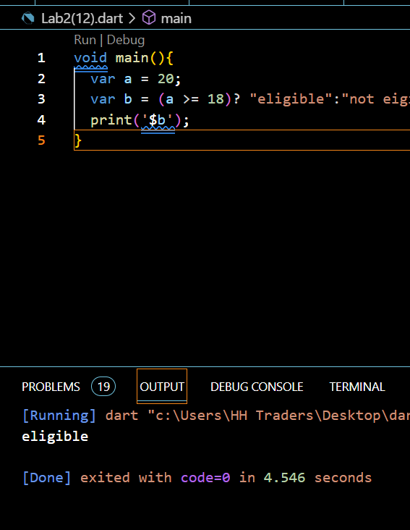

**13) Write a Dart program that checks if a user is eligible for a discount on a purchase, using the ternary operator.**

